Grade 1
One Leaf Many Leaves

Description: | Students will:  Draw a leaf.  Create a script that makes the leaf move forward and turn and bounce.  Experiment with the numbers in the script.  Change the size of the leaf drawing.  Make patterns with copies of the leaf in various sizes.
Project View | 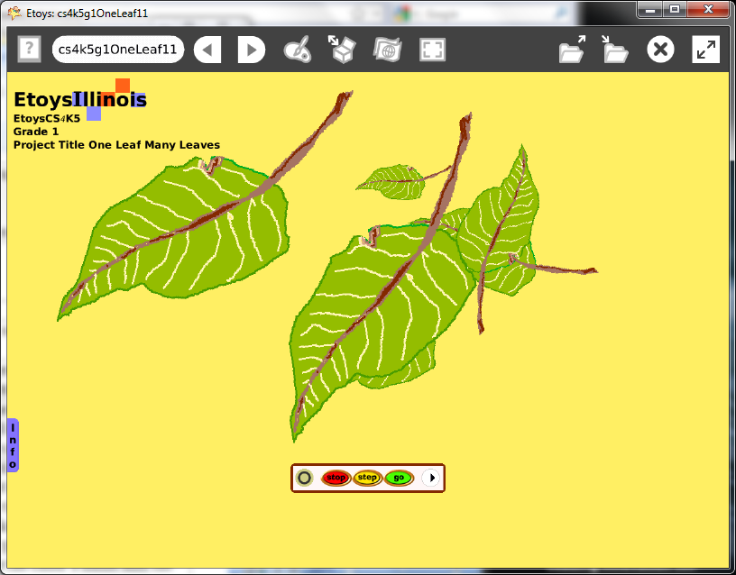
Subject: | Math, Art
Etoys Quick Guides | Click the question mark in Etoys to open the set of interactive tutorials for basic tools and techniques.
Vocabulary: | Patterns, big, small, up, down, beside, between, before, forward, turn, bounce, motion, increase, decrease, bigger, smaller, copy, turn, rotate
Lesson 1: | This project introduces many tools, techniques and concepts. Give students time to develop their knowledge and skill. Thorough learning, deep learning, and processes are the valuable aspects of this project.
Paint Tools: Brushes  Navigator Bar: Keep Find Projects | Ask students to draw leaf from their imagination. Talk with them about the parts they drew. Give them time to look at other student’s drawings and talk about what they see. Give them time to add to their drawing.  Keeping a project has many steps and will take time for students to type the project name, open a folder, and save the project. A good convention for naming projects is to combine the child’s name and the topic, for example: kateLeaf
Lesson 2:  Halo of Handles:  Make the Halo Show  Halo of Handles: Size Color Copy  Halo of Handles: Rotate | Give students a leaf, or take them outside to collect a leaf, to draw from life. Give students time to look at their leaf; discuss colors, shapes, size and other details. After students have drawn a leaf, this project should be kept as the basis for other lessons in this set.  Make copies of the leaf, change their color and size. Use the rotate handle. Make patterns. Ask neighbors if they can find the pattern.  Open a halo, highlight the word sketch and type leaf as the new label. This step takes time but when students open the Viewer they will find every tile starts with the word leaf.  Save the project.
Lesson 3:  Halo of Handles: Viewer  Script Tiles: Forward by  Script Tiles: Forward by and Turn by  Script Tiles: Bounce Motion | Open a leaf’s Viewer with the halo. Make a script with a forward by tile and click the clock to start and stop it. Give students time to experiment with different numbers. Discuss what happens to the motion of the leaf when the number is less than five and when it is more than five.  Experiment with zero in the script and discuss the result.  Show students there are numbers less than zero. Give them time to experiment with many numbers. Remind them to say the number as they type it.  Add a turn by tile in the script and change the number. Experiment numbers in both tiles. Discuss.  Add a bounce tile to the script and experiment with motion. Discuss the effect of the bounce tile. Keep the project.
Lesson 4:  Halo of Handles: Size, Color, Copy  Supplies: All Scripts | Make copies of the scripted leaf. Each copy will have the same script.  Use an All Scripts button from Supplies. Experiment.  Ask students to put all the leaves in different locations of the screen and start the scripts: the bottom of the screen, top, right, left, and stacked.  Give them time to try their neighbor’s project.
Lesson 5:  Halo of Handles: Size, Color, Copy  Halo of Handles: Rotate | Experiments with size and orientation are the focus of this lesson.  Ask students to change the size of some of the leaves.  Ask students to change the orientation of some of the leaves.  Make patterns with the sizes and with the motion. Give students time to play with these ideas. Ask them to describe what is happening in their project and how they did it.  Ask them to analyze a project by someone else in class by looking at the scripts and predicting what will happen before they start the scripts.
Standards: | Common Core Standards  Mathematics:1.G.1  Bloom’s Taxonomy/Cognitive Domain:  Application: demonstrates, uses  Analysis: compares  Synthesis: explains, predicts  NETS  1. a, b, c  2. a  4. a, b
Resources: | Etoys Help Quick Guides: always available in Etoys. Open Etoys and click the question mark to open a set of interactive tutorials of basic tools and techniques.  www.etoysillinois.org projects, lesson plans, software download  www.mste.Illinois.org more math, science, and technology resources  www.corestandards.org Common Core Standards  www.squeakland.org software and Etoys projects  www.nctm.org Standards and Focal Points for each grade level
kh January 2011

